1. Login Root User email : IAM -> User groups -> Create Group

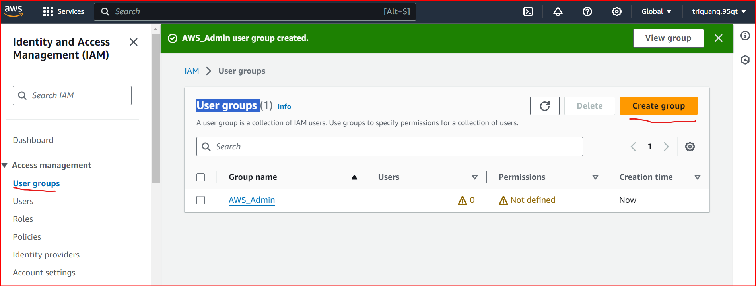

1. Click AWS_Admin  
   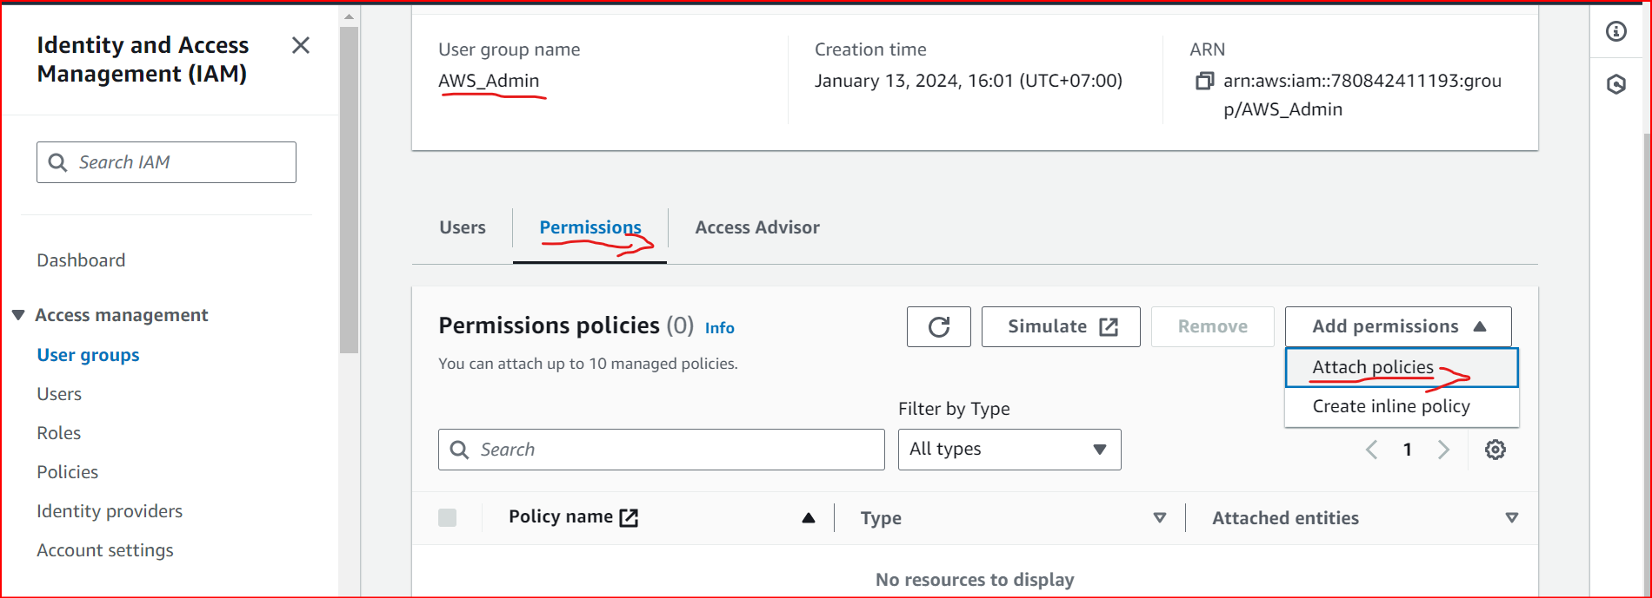
2. Click Attach policies -> Seach IAM -> Select IAMFullAccess -> Add Policies  
   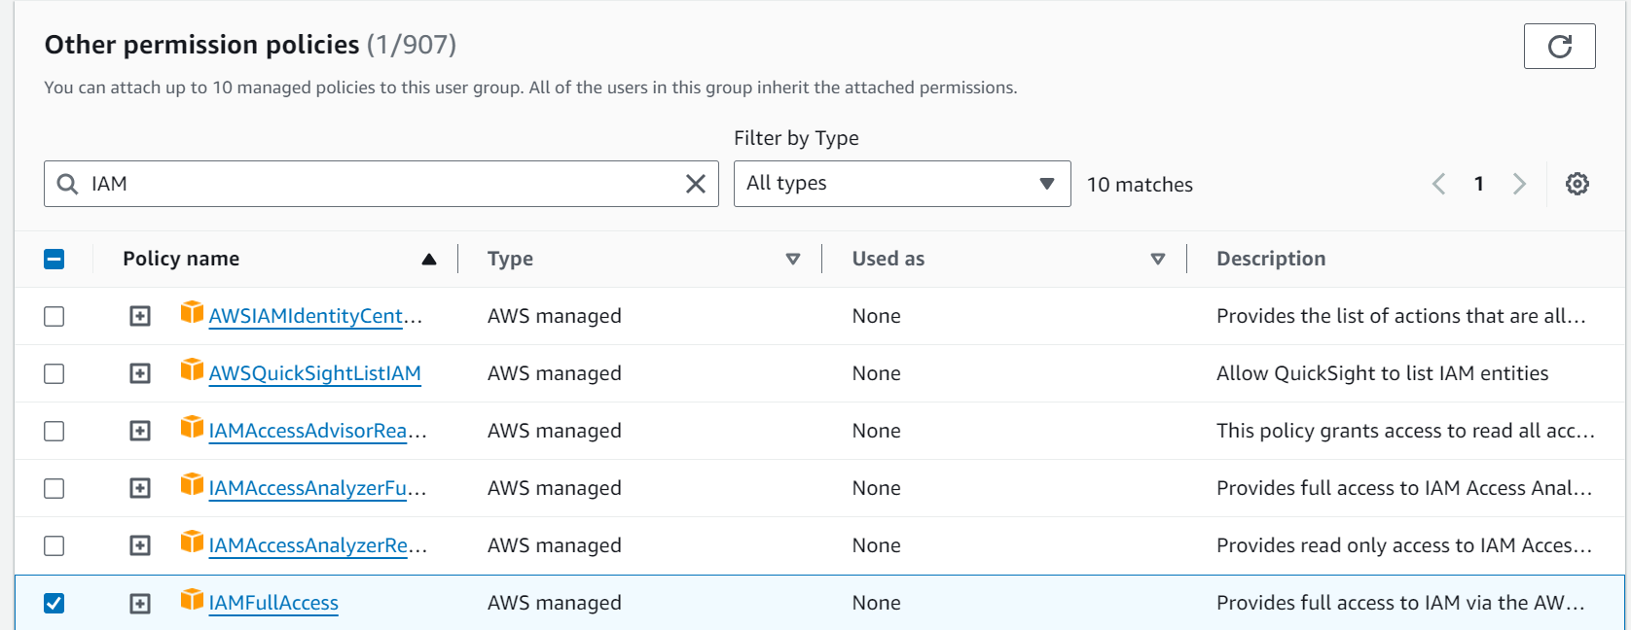

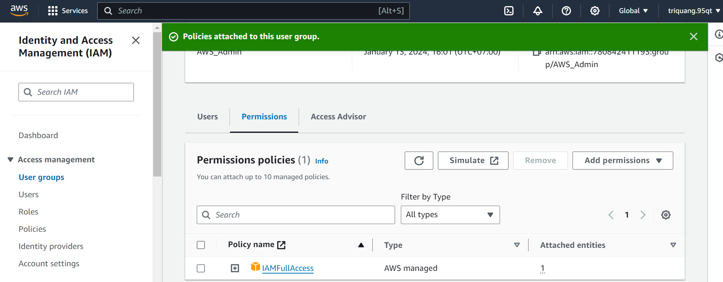

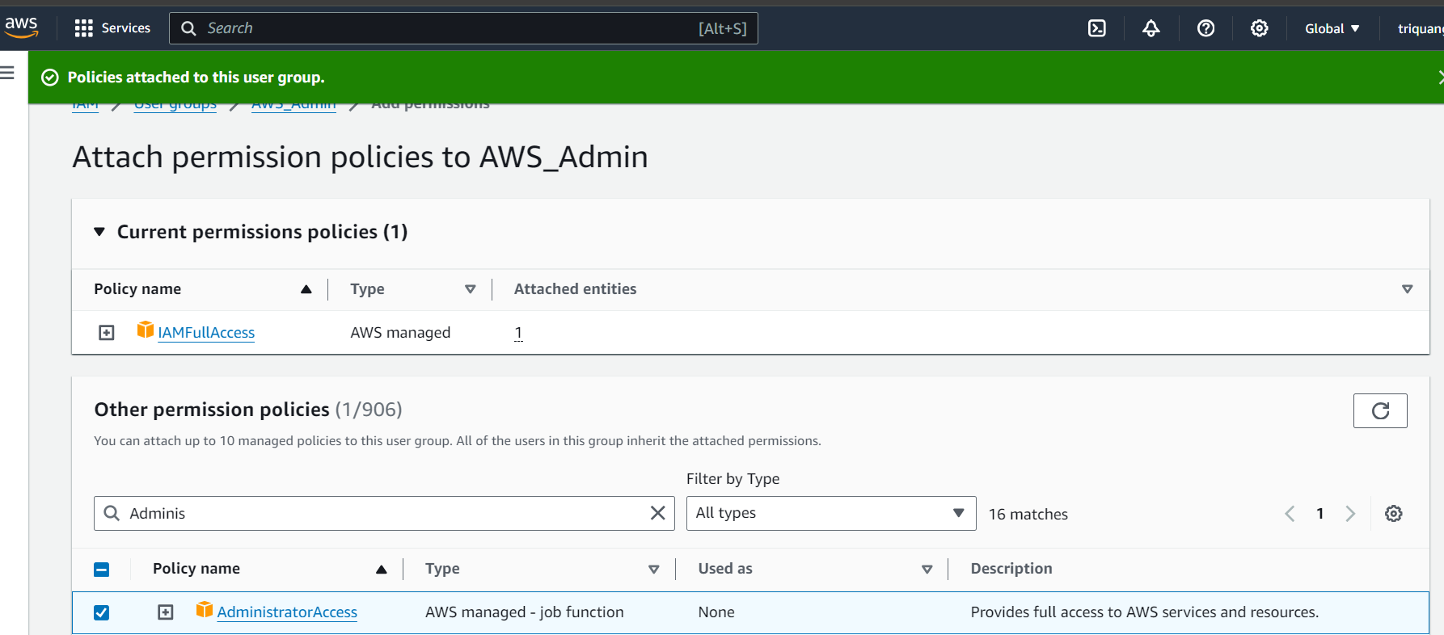

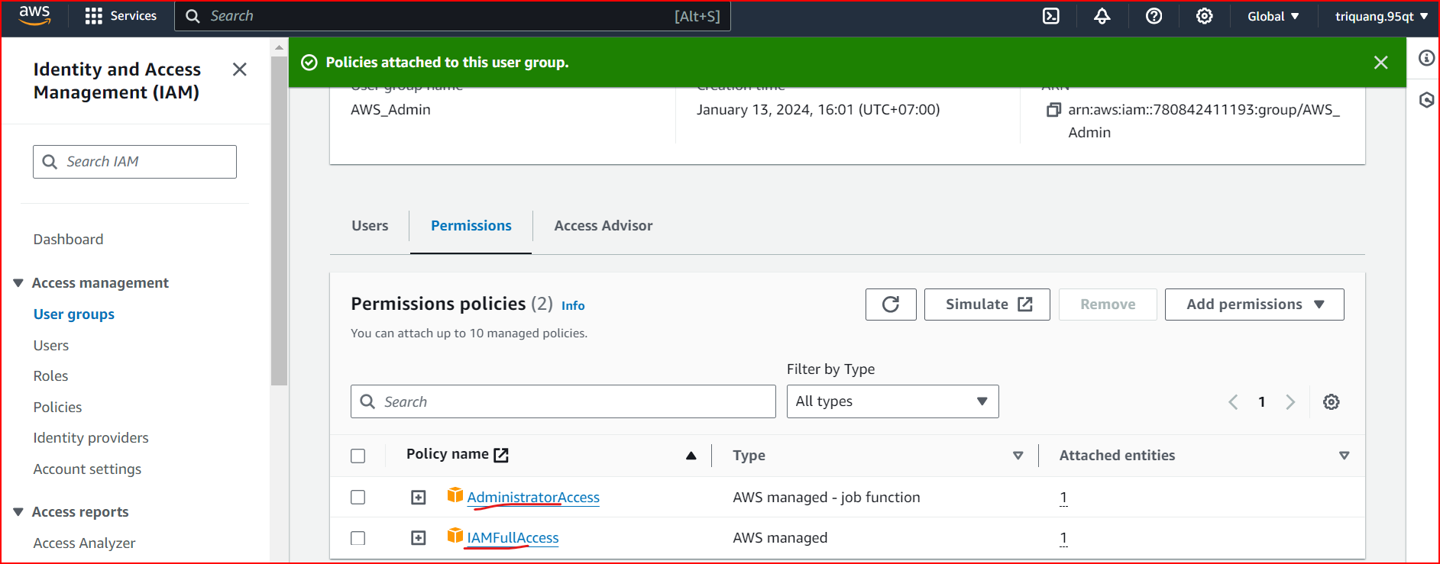

1. Click User -> Create user

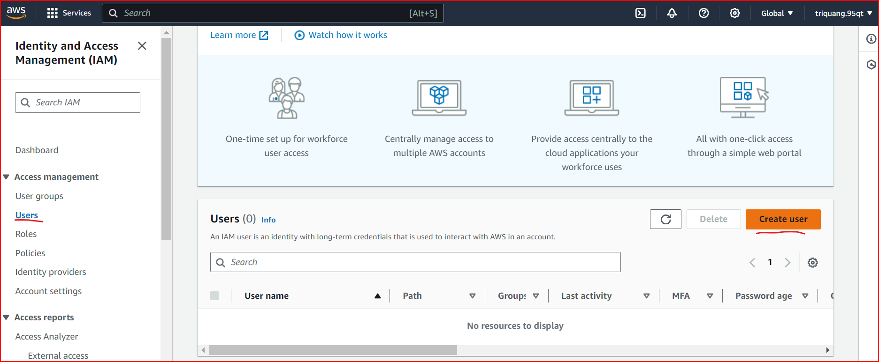

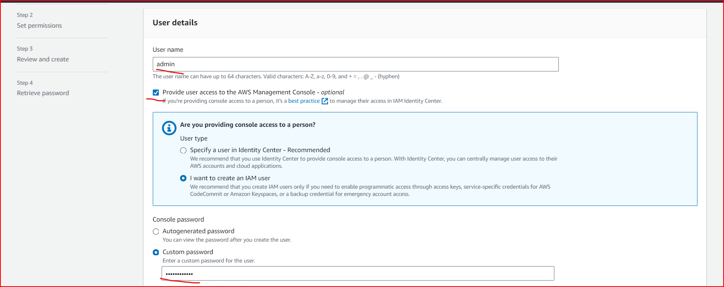

Click Next

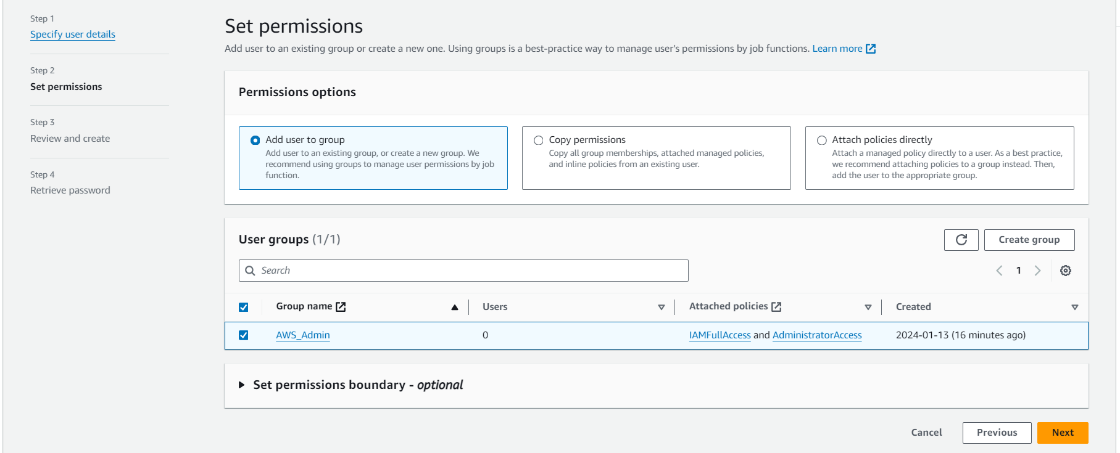

1. Click next -> Create User Success

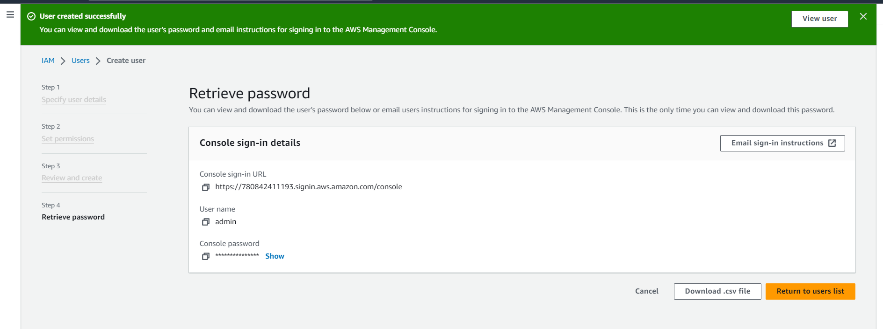

1. SignIn AWS as IAM User -> Click Dashboard -> Copy Account ID -> Sign Out

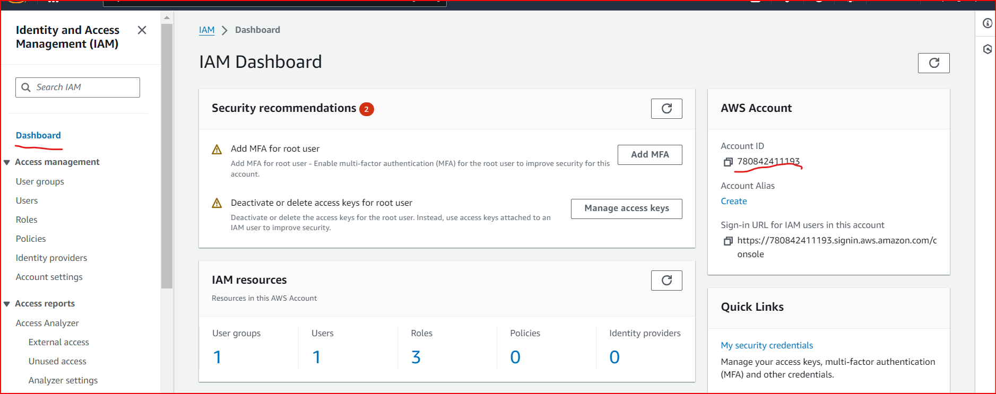

1. Login IAM User with Account ID

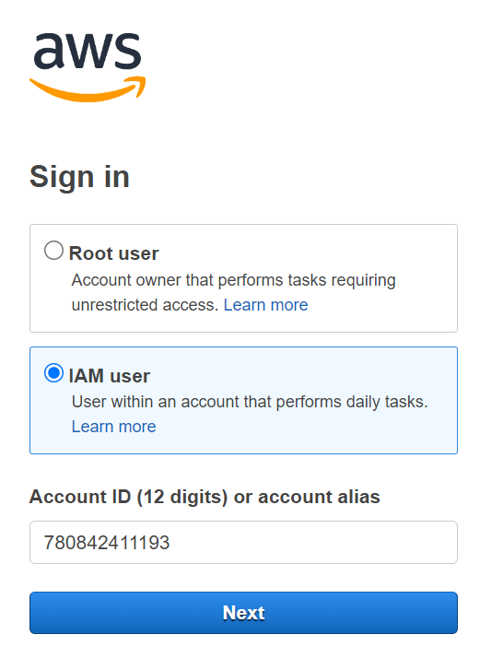

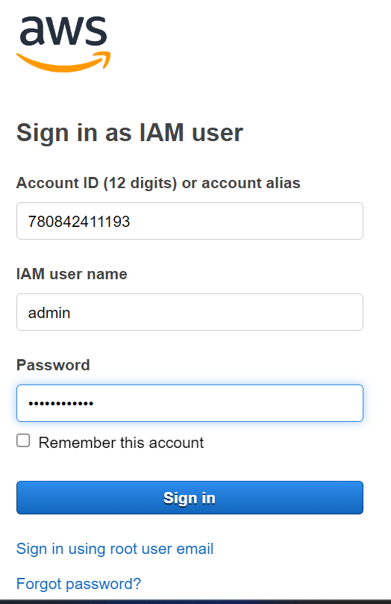

1. Create IAM Group and User for Amazon S3 -> Click User groups -> Create group

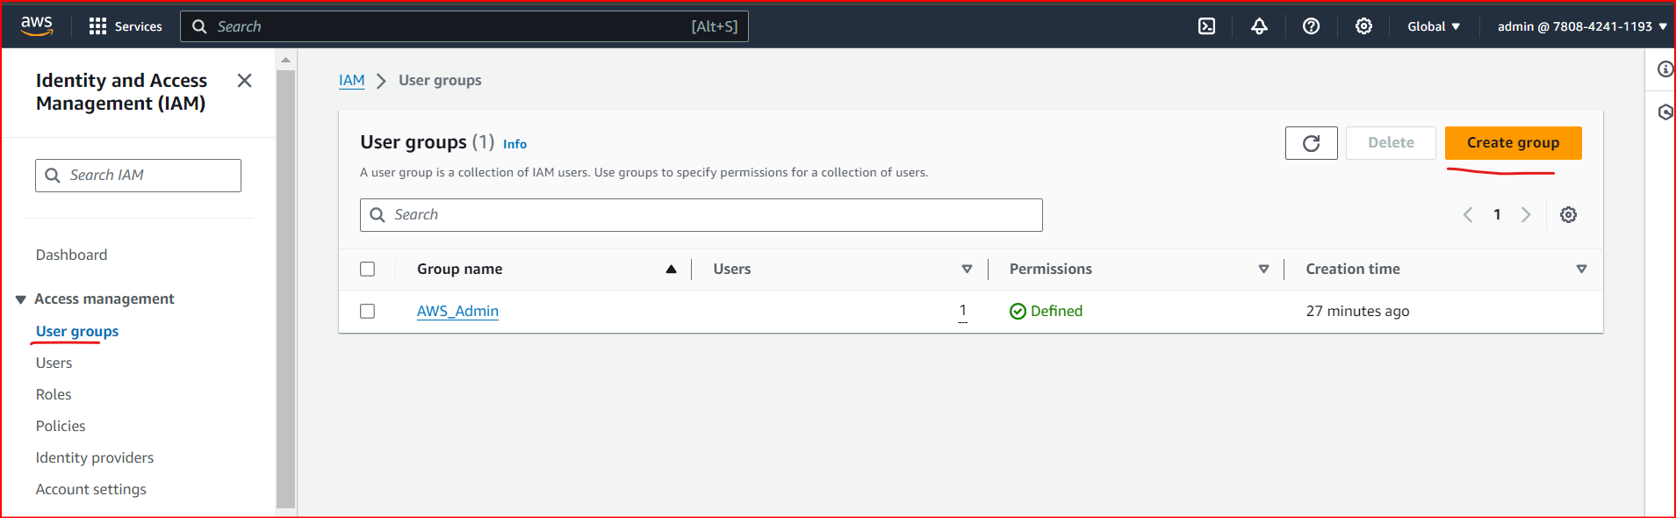

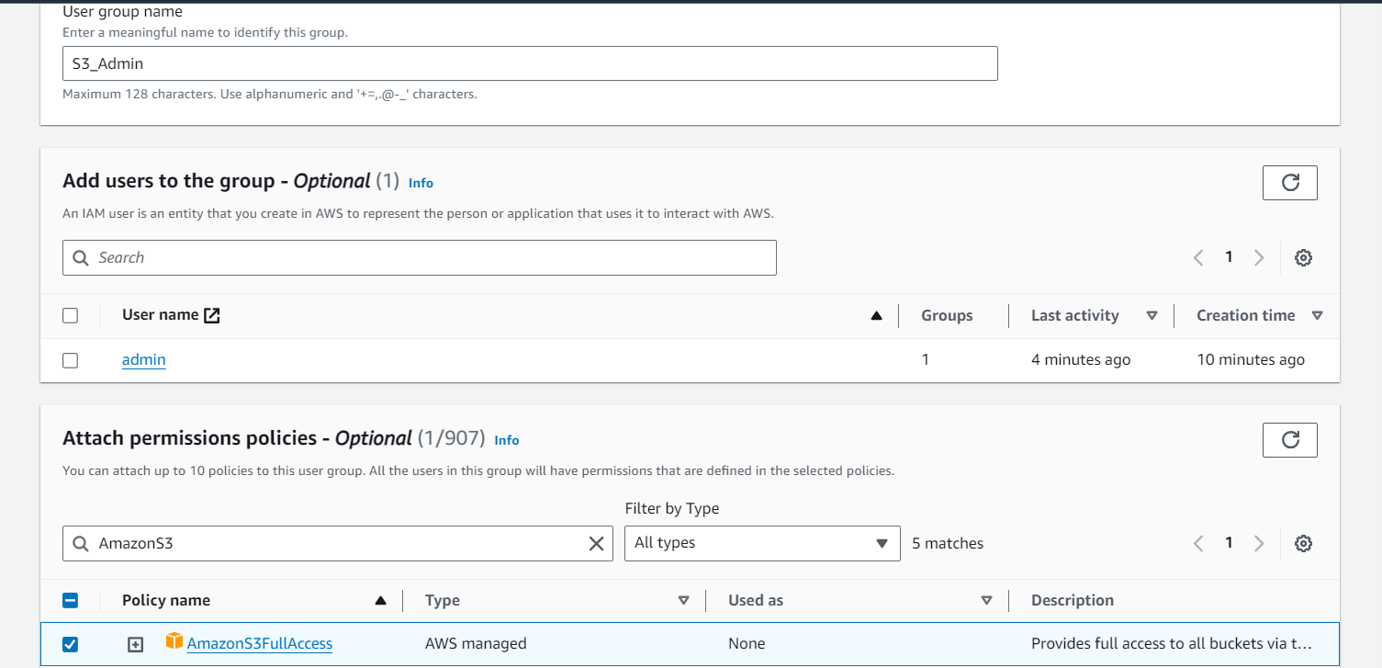

1. Click Create Group

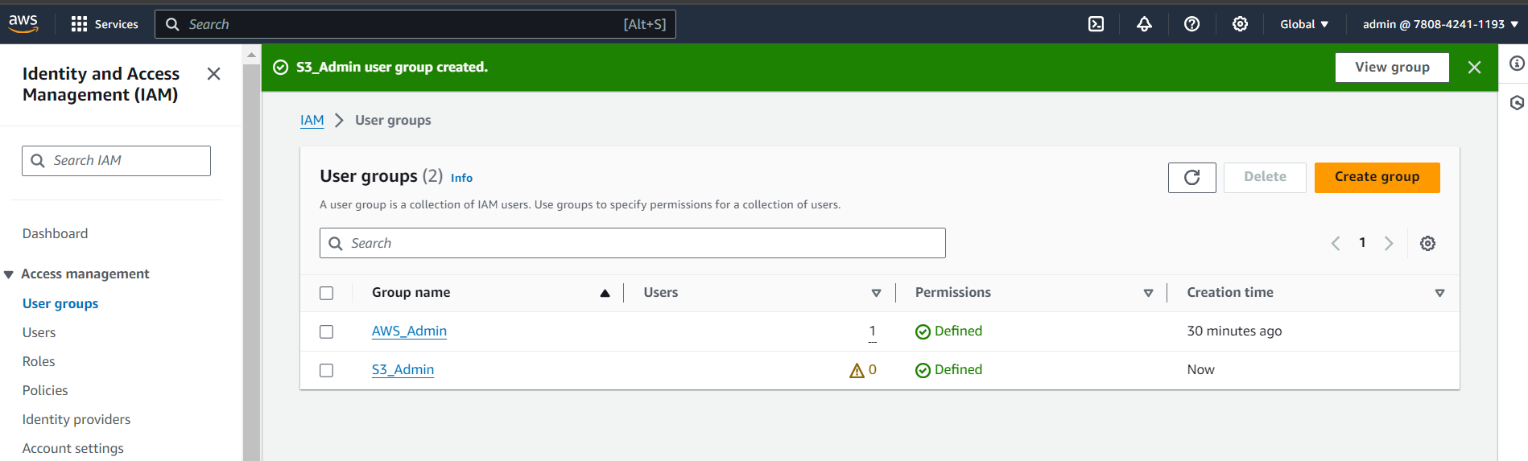

1. Click User -> Create user

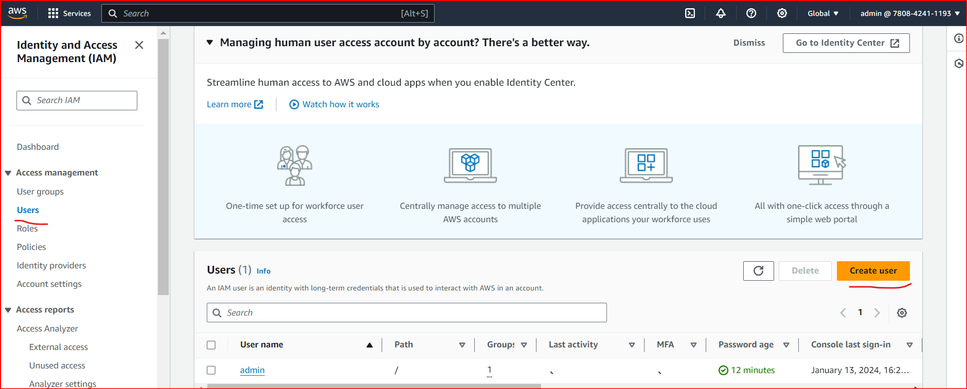

1. Next Step

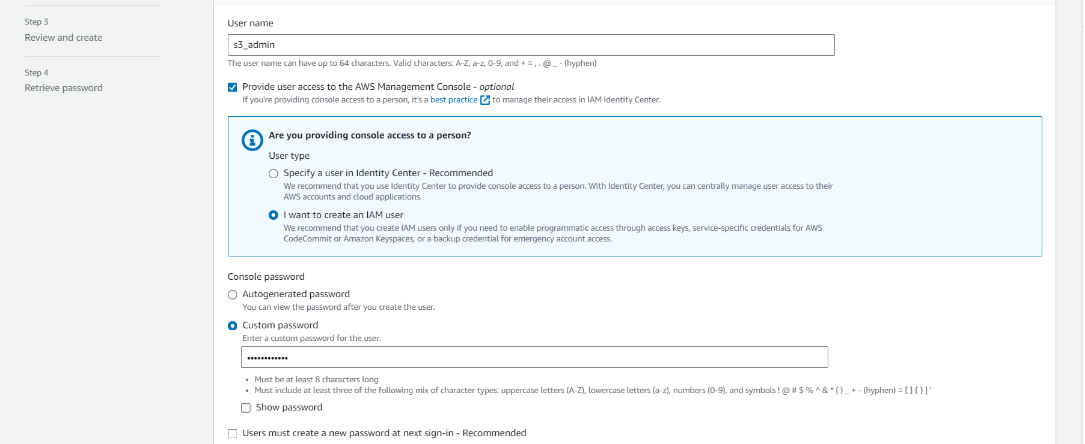

1. Select S3_Admin

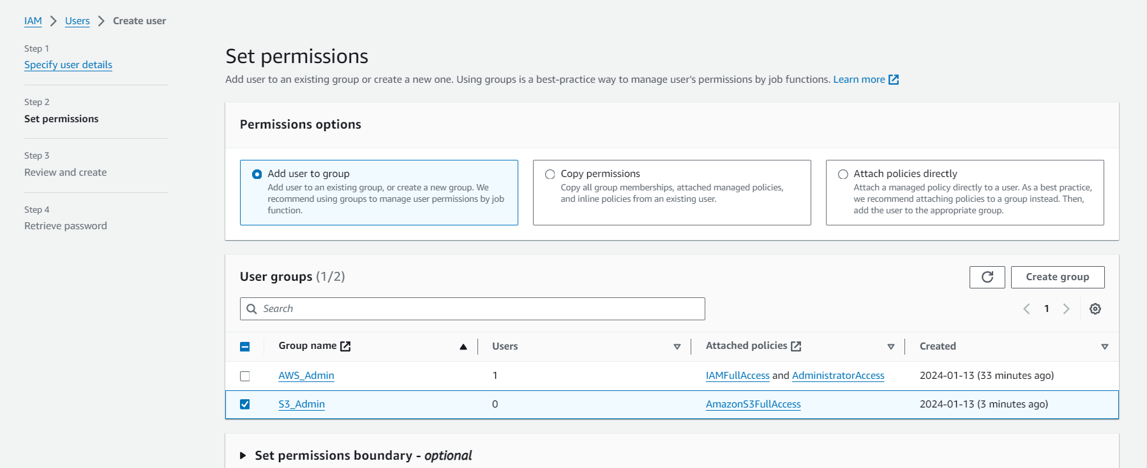

1. Next Step -> Create User

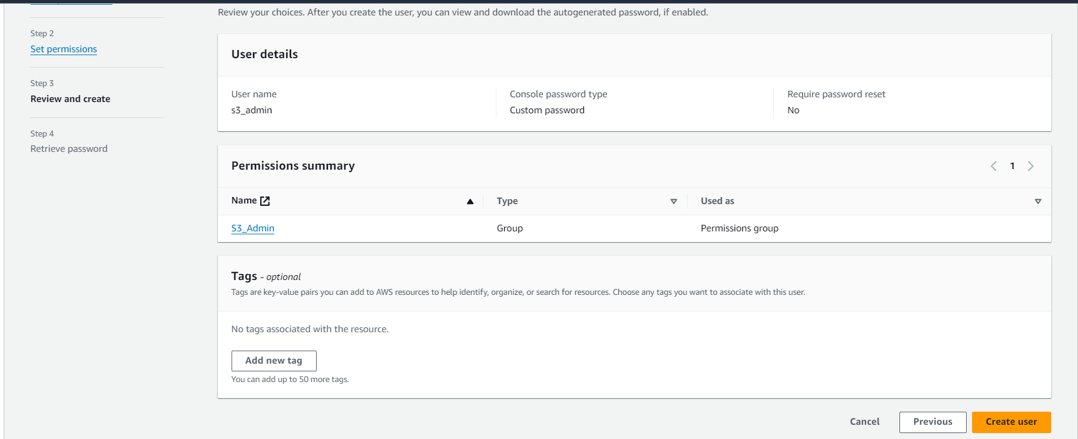

1. Signin AWS as S3 Admin User

Copy Account ID and Signout

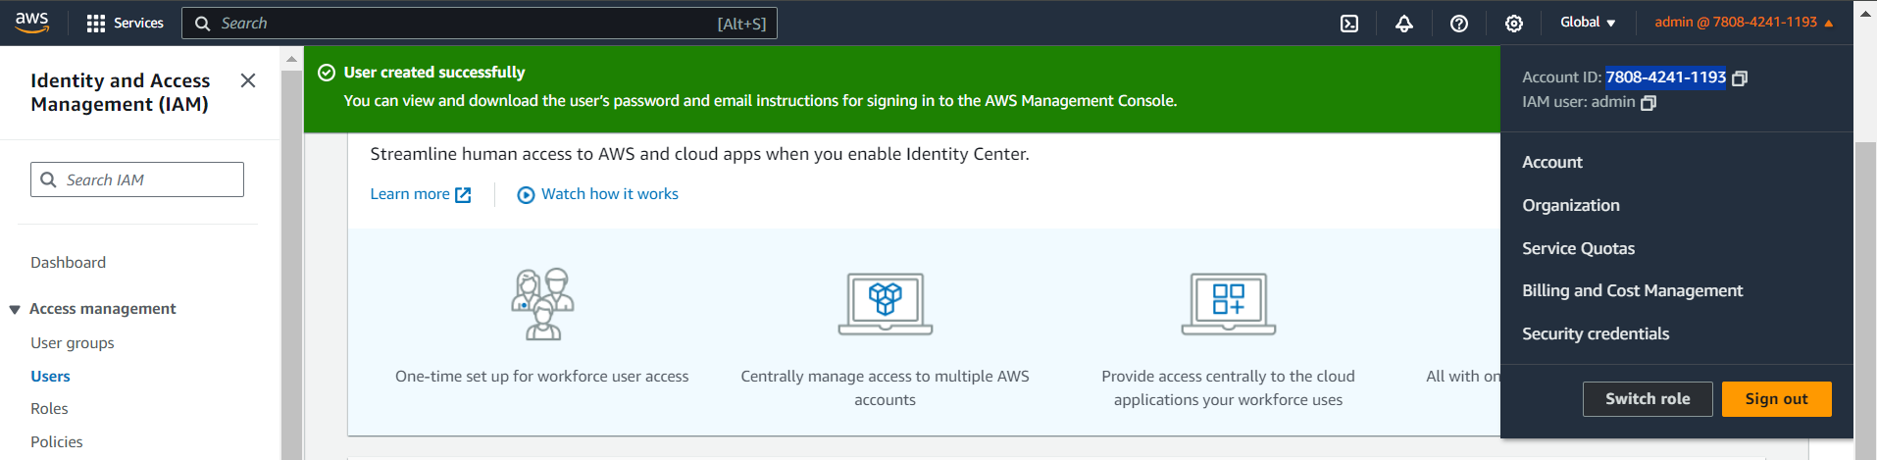

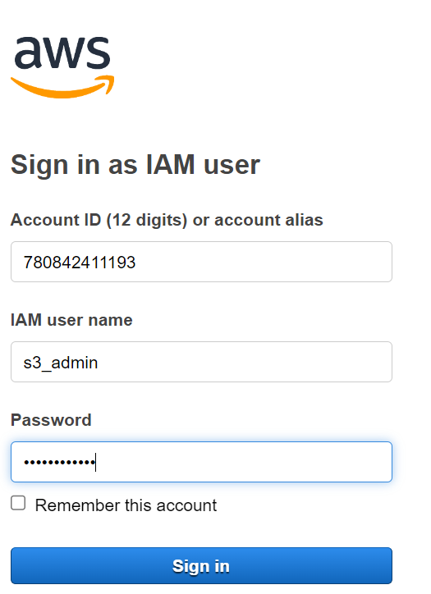

1. Search Amazon S3 -> Buckets -> Create bucket

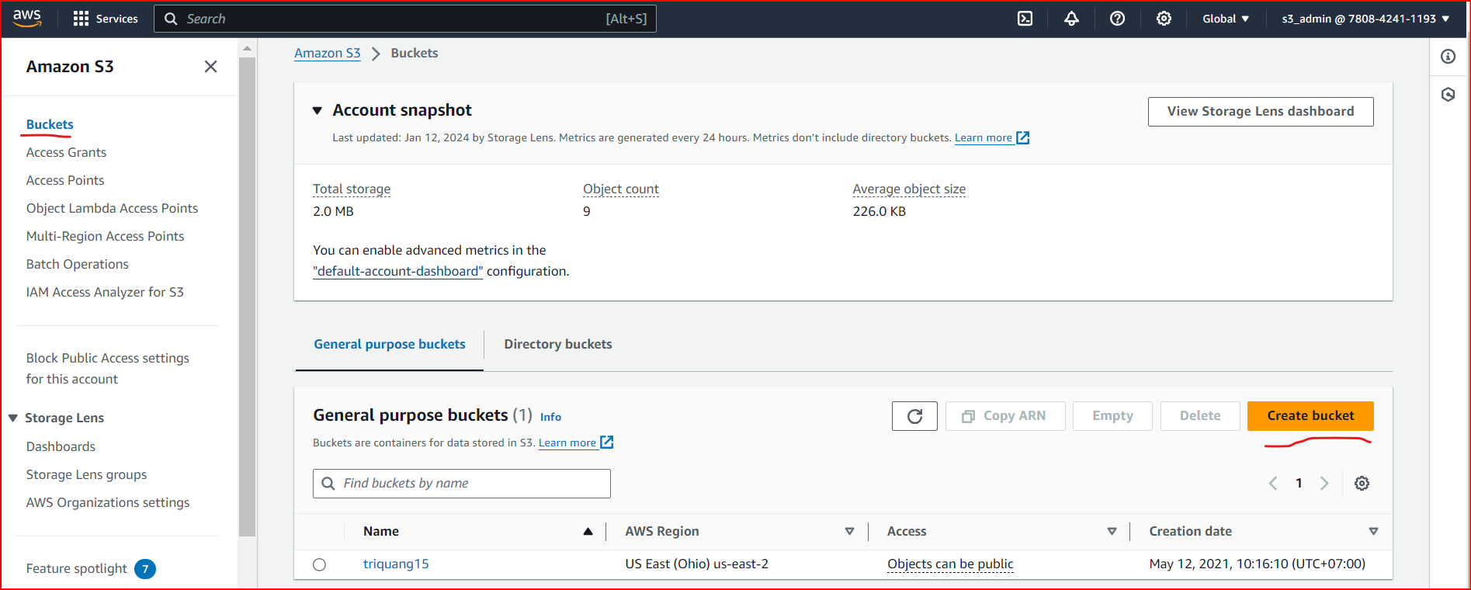

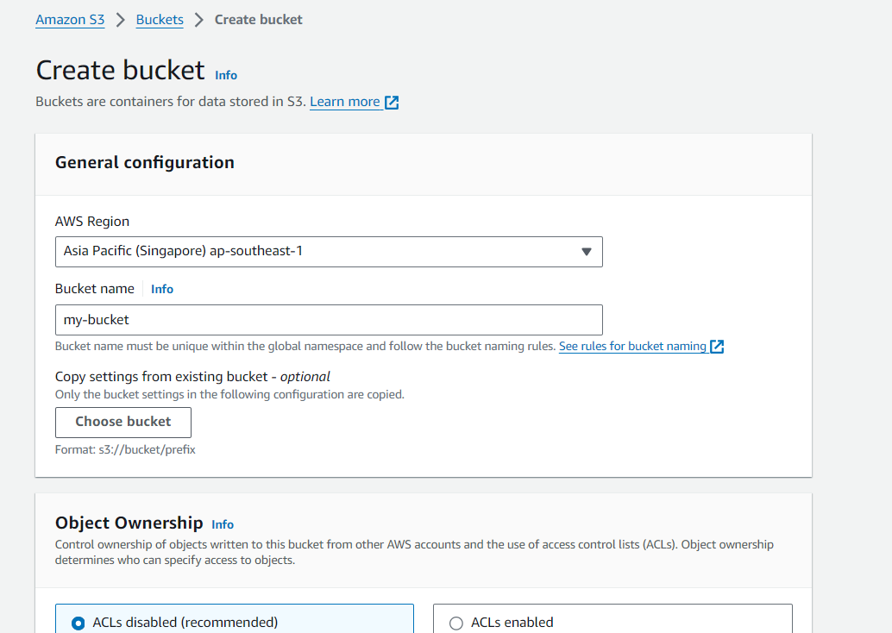

1. Edit Block public access -> Uncheck Block public

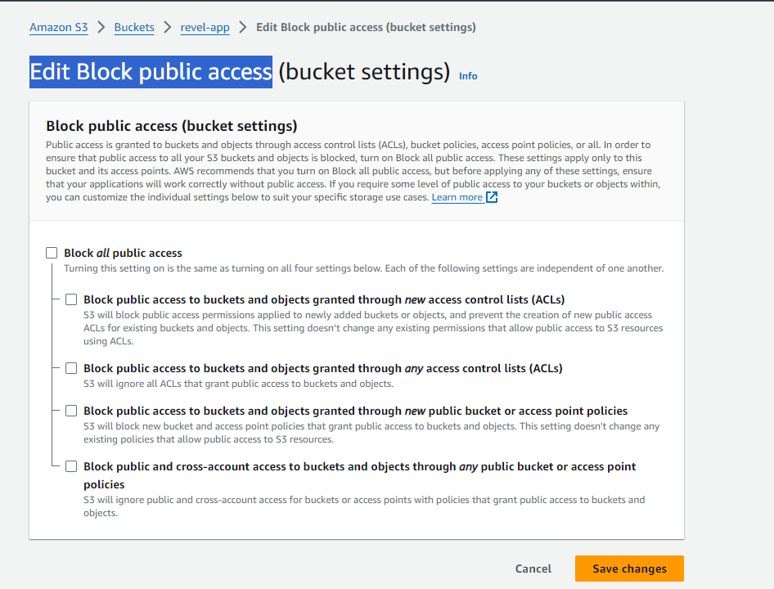

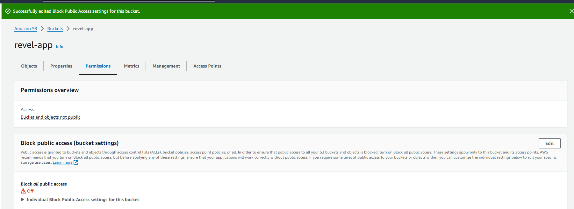

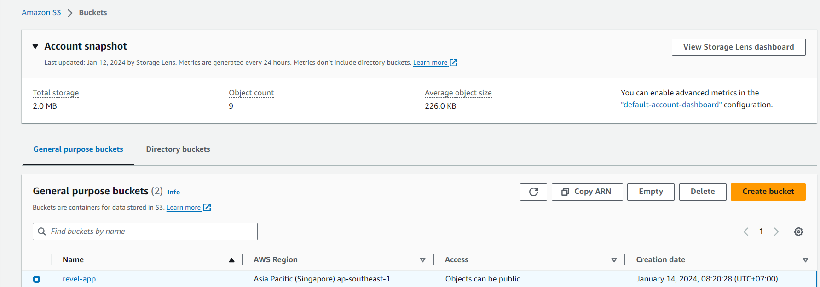

1. Upload files to Amazon S3

user-photos, brand-logos, category-images, product-images, site-logo

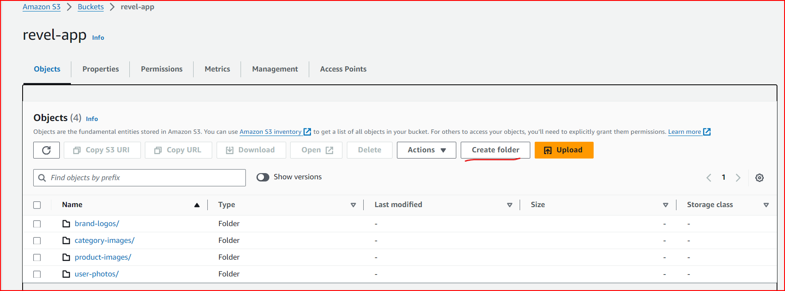

1. Next step -> Click create folder

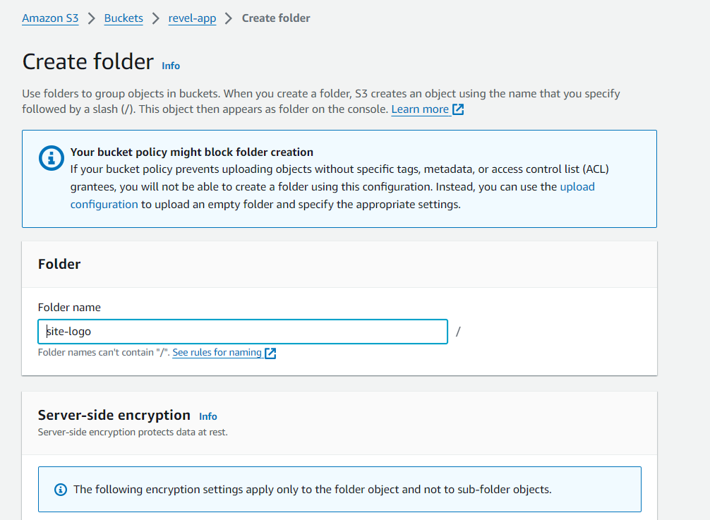

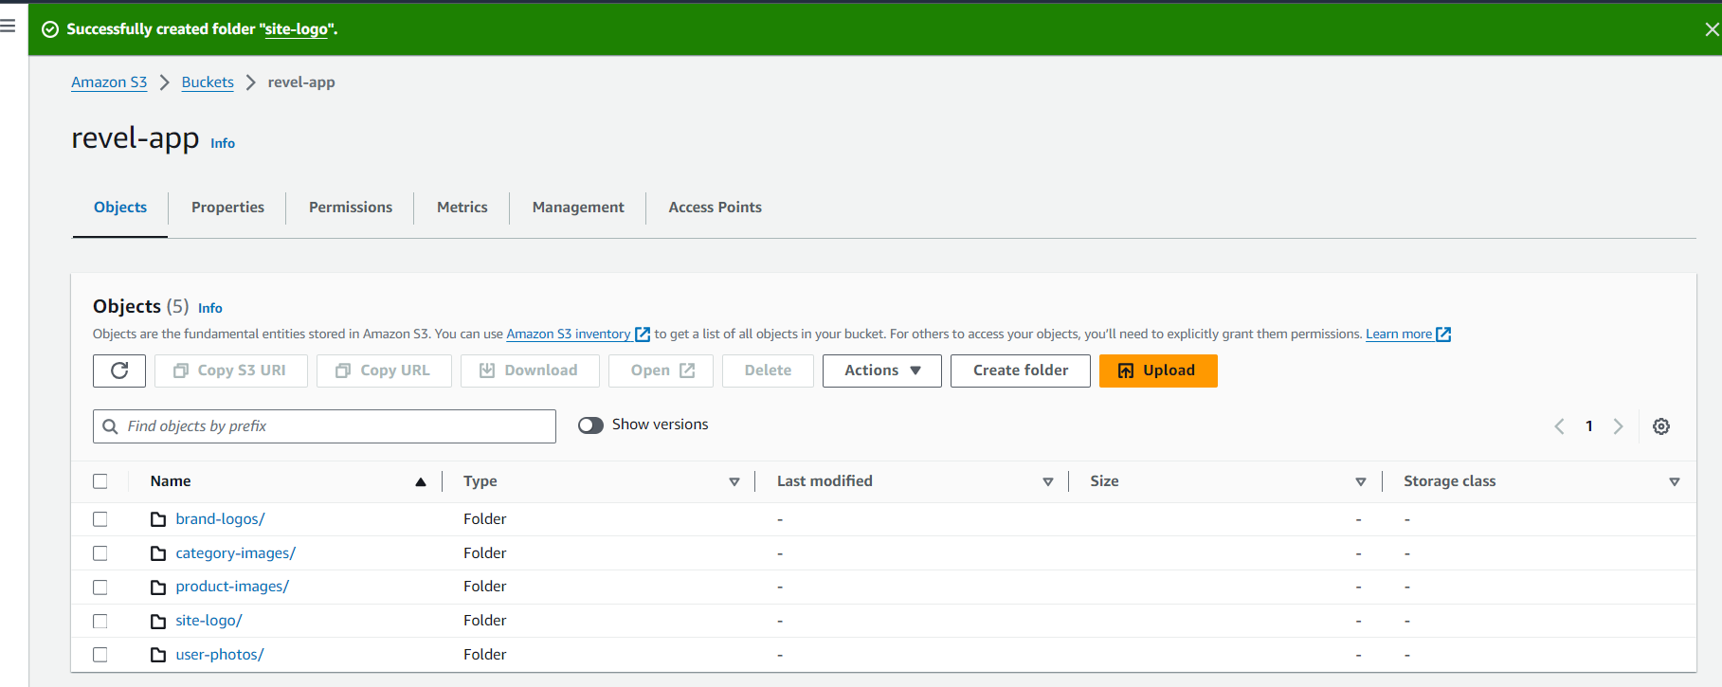

1. Setup environment variables for Amazin S3

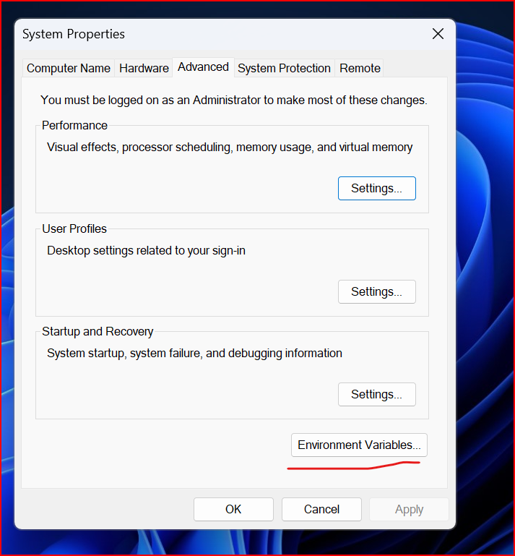

1. Add new variables -> Click Ok

* Variable name: AWS_BUCKET_NAME, AWS_REGION
* Variable value: amazon-files, ap-southeast-1

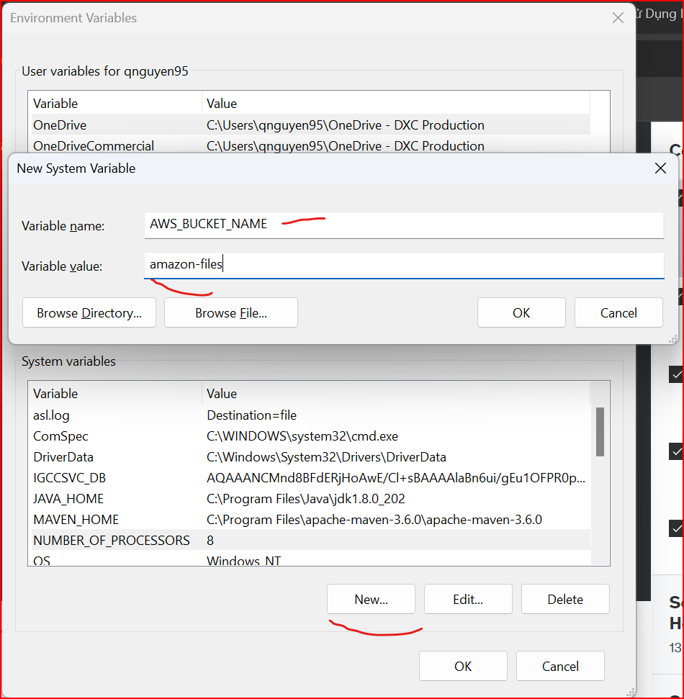

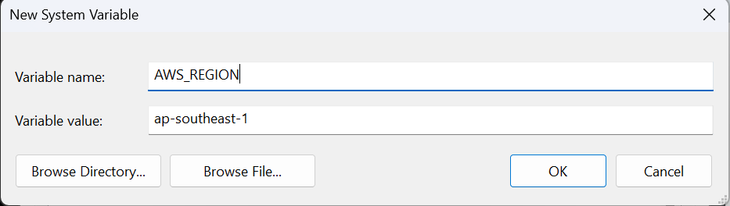

1. Next Step -> Restart Windown
2. Test Code - > Successfully

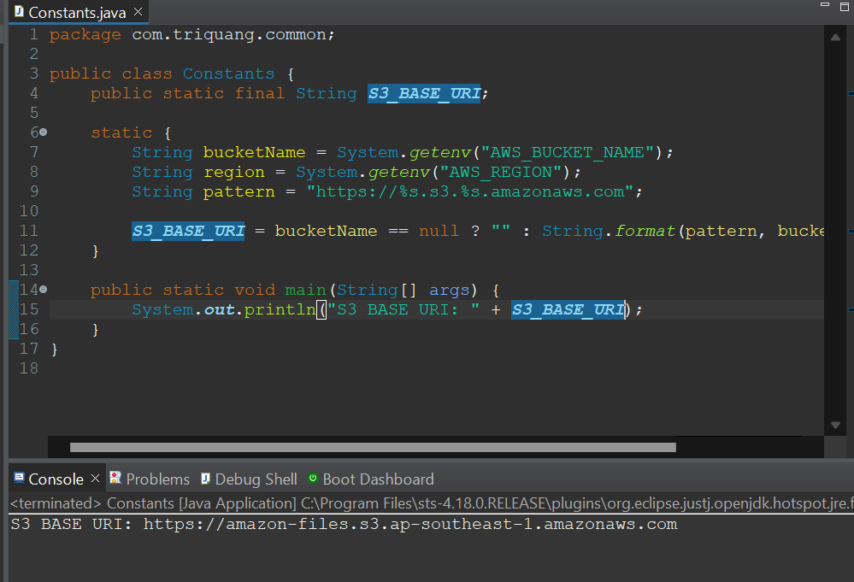

** Login Account ID admin -> Create user

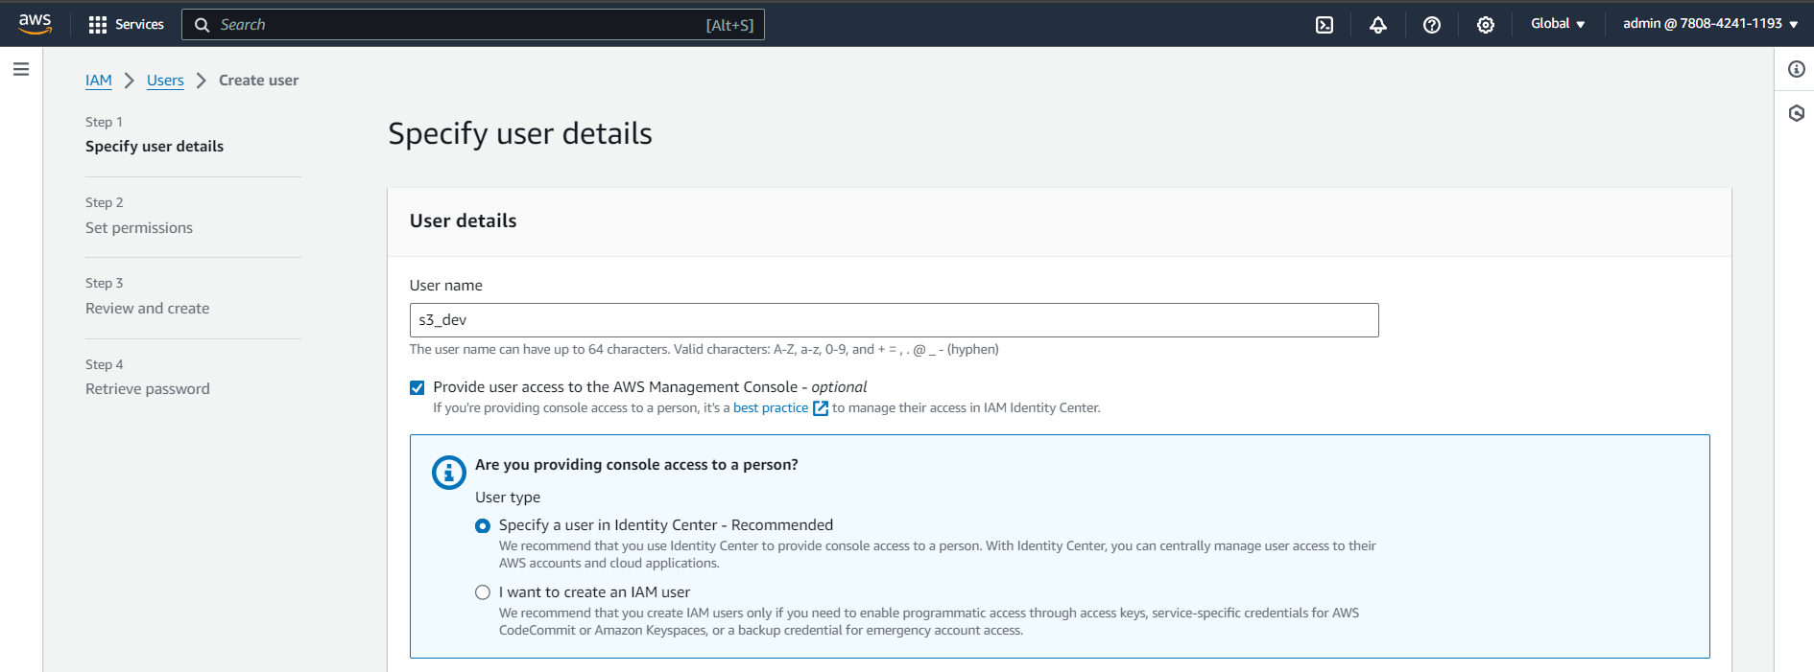

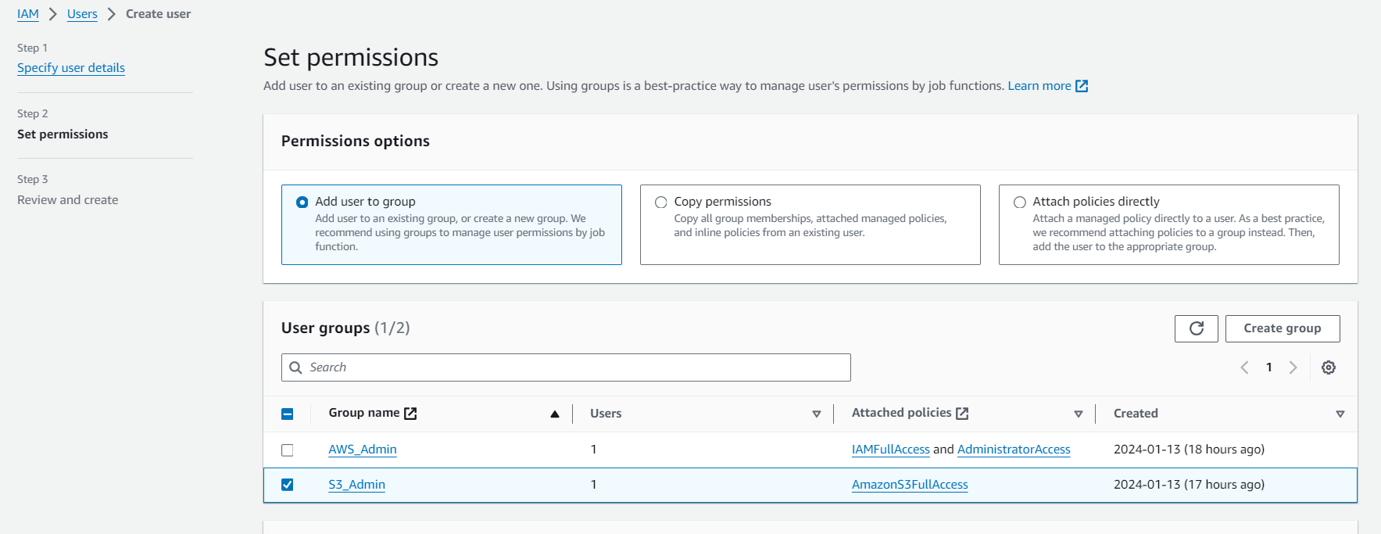

Create Access Key

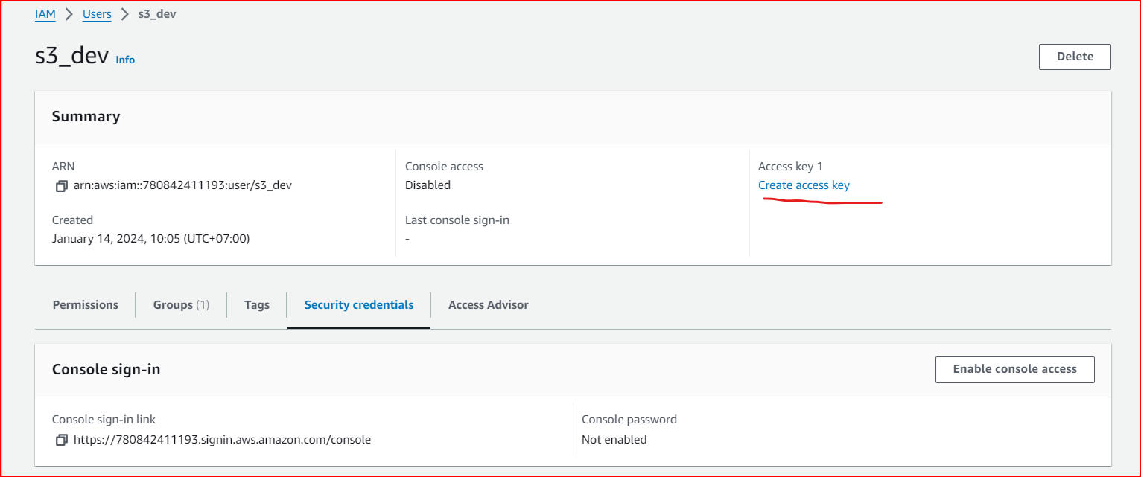

Next Step -> Select Third-party service

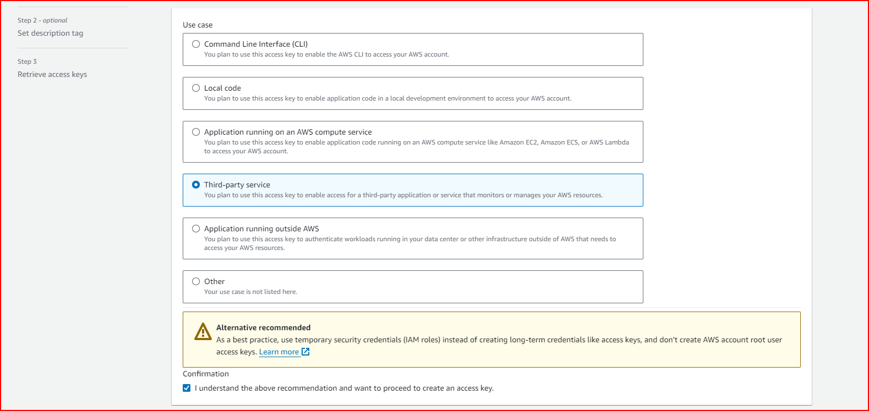

Next Step

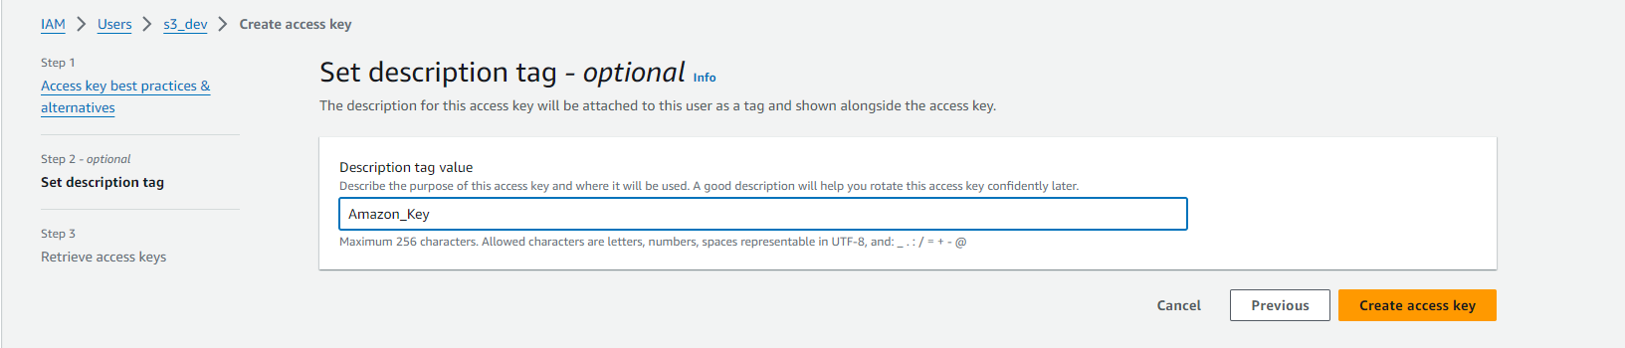

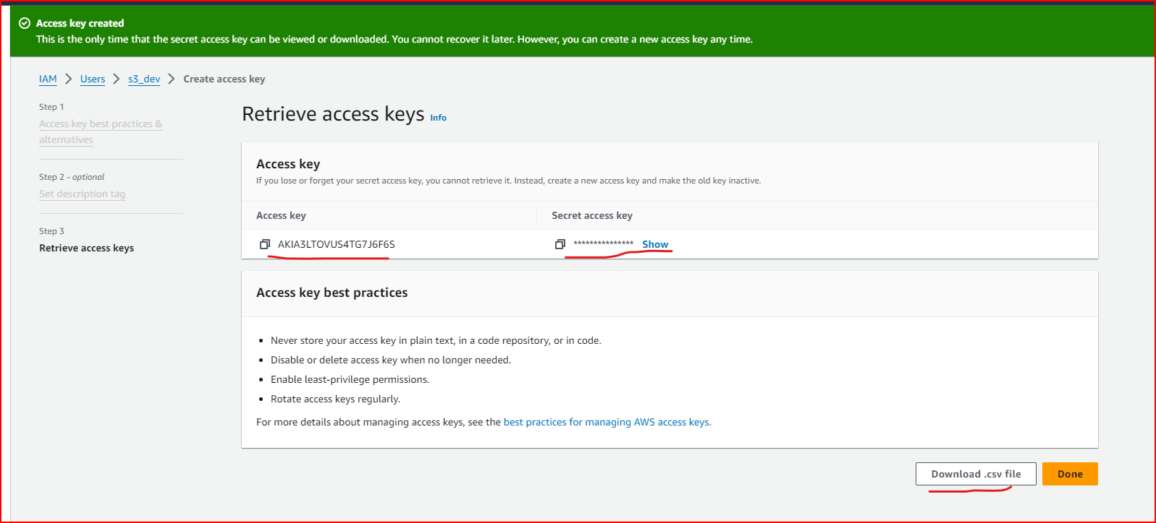

Add Environment

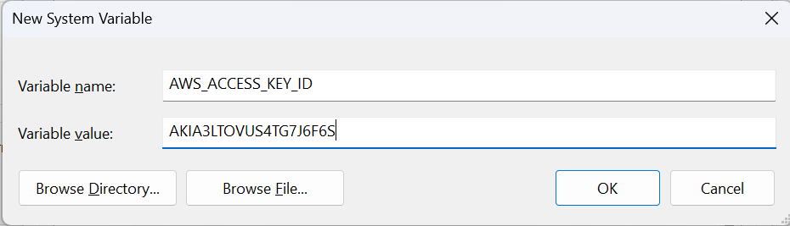

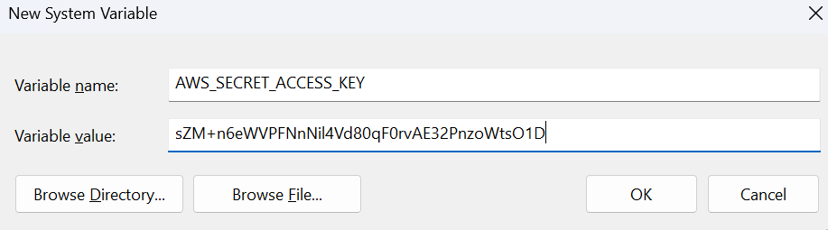

Done

